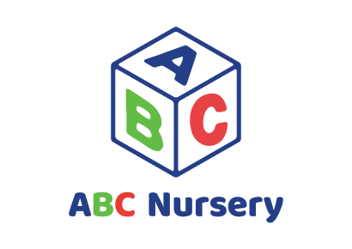
Corona Virus (COVID 19)
Hand washing Policy

PURPOSE
This policy to support children, staff and parents the importance of handwashing. Proper and regular handwashing can help prevent the spread of illness and virus. Good hand hygiene is the most effective way of preventing transmission of infection. Staff and practitioners are to support children in using the proper technique for hand washing.

DEFINITIONS
- Procedure: an established or official way of doing something
- MOHAP: Ministry of Health- The government entity that deals with all health related issues in the UAE
- PPE: Personal Protective Equipment (i.e., masks, aprons, gloves)
- Hand sanitizer: an alcohol based hand cleanser that can be used when soap and water are not available.

POLICY STATEMENT
- The policy and considerations may evolve and be built upon as the situation deepens and new precautionary measures have been introduced and practices have been reflected upon.
- This policy aims to work in partnership with parents and trust that everyone including staff and children understands and follows.
- Handwashing training will be given to all staff regularly and handwashing education is included in lesson plans for children. These will be recorded and kept.
- Hand washing facilities are available in each childcare room, toilets, nappy changing areas, food preparation areas and cleaning areas.
- Children can avail of the hand washing facilities when they need and they will be encouraged and supported to practice this.
- Guidelines on handwashing are displayed in the toilets. These guidelines incorporate visual images that are appropriate for staff and children Importance of handwashing posters will also be displayed around the setting.
- Staff must regularly wash their hands with soap and water for at least 20 seconds before the following:
- The start of the work schedule
- Eating, handling/preparing food or assisting/feeding a child;
- Preparing meals, snacks and drinks (including infants’ bottles).
- Give medication
- Staff must complete handwashing after the following:
- Using the toilet or helping a child to use the toilet;
- Nappy changing/handling potties;
- Playing, or handling items, in the playground – e.g. toys, sand, water;
- Handling secretions e.g. from a child’s nose or mouth, from sores or cuts, blood or body fluids (faeces, vomit, spit, nappies, pads, pus and urine);
- Handling or dealing with waste or rubbish;
- The removal of disposable gloves and/or aprons;
- Washing/handling of soiled clothes;
- Coughing or sneezing;

- The rate of handwashing will be significantly increased. In the schedule, it is reflected that every hour, after each activity, children will be washing their hands with soap and water for 20seconds, they will be taught different songs to last 20 for seconds to wash their hands. Posters will be displayed. Adequate supplies of soap and paper towels are provided at identified handwash stations.
- Hand sanitizer should only be used in areas where hand washing facilities with soap, water and paper towels cannot be provided. Hand sanitizer is not required after hand washing with soap and water. A hand sanitizer station will be provided for visitors to use.
- Hand sanitizer provided are skin allergy safe, but efficient enough to sanitize, as recommended 70% alcohol content for children and 90% for adult.
- All members of staff have also been given their own hand sanitizers that can be clipped onto their uniform for easy access during the day

IMPLEMENTATION DOCUMENTS
Please refer to the following documents to ensure the effective implementation of the policy:

- MOHAP Guidelines
- Handwashing Posters

Policy created by: Ahlam Ibrahim
On: September 2020

Reviewed and updated:

